File Submission:

For this homework, each exercise needs to be submitted in the following format, i.e. all exercises and required files in its own folder. These folders need to zipped in one folder called LastName_File_Activities.zip and submitted. Follow the screenshot below.

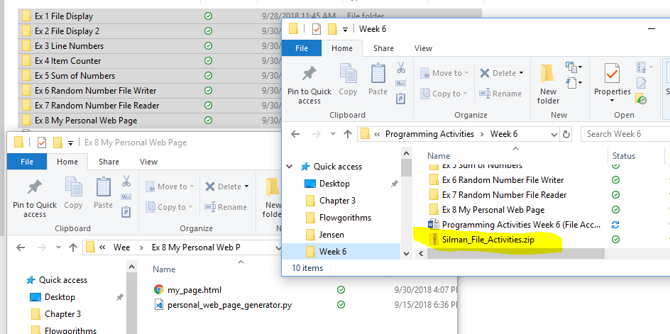

Exercise 1: File Display

Using a file containing a series of integers that is named numbers.txt Write a program that displays all the numbers in the file.

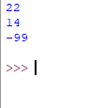

Exercise 2: File Display 2

Write a program that asks the user for the name of a file. The program should display only the first five lines of the file’s contents. If the file contains less than five lines, it should display the file’s entire contents.

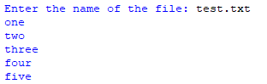

Exercise 3: Line Numbers

Write a program that asks the user for the name of a file. The program should display the contents of the file with each line preceded with a line number followed by a colon. The line numbering should start at 1.

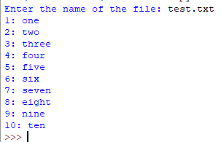

Exercise 4: Item Counter

Assume a file containing a series of names (as strings) is named names.txt and exists on the computer’s disk. Write a program that displays the number of names that are stored in the file.

(Hint: Open the file and read every string stored in it. Use a variable to keep a count of the number of items that are read from the file.)

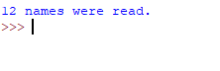

Exercise 5: Sum of Numbers

Assume a file containing a series of integers is named numbers.txt and exists on the computer’s disk. Write a program that reads all the numbers stored in the file and calculates their total.



Exercise 6: Random Number File Writer

Write a program that writes a series of random numbers to a file. Each random number should be in the range of 1 through 500. The application should let the user specify how many random numbers the file will hold.

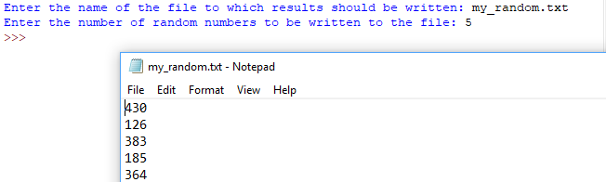

Exercise 7: Random Number File Reader

This exercise assumes you have completed Exercise 6, Random Number File Writer. Modify the program so that it also reads the random numbers from the file, and displays the following additional data:

* + The total of the numbers
  + The number of random numbers read from the file



Exercise 8: Web Page Generator

Write a program that asks the user for his or her name, then asks the user to enter a sentence that describes himself or herself.

Once the user has entered the requested input, the program should create an HTML file, containing the input, for a simple Web page. Here is an example of the HTML content, using the sample input from the user:

